Project Design Document

1. Design Intent
What experience are you trying to create?
A living desk companion — a lamp that doesn't just illuminate but listens, responds, moves expressively, and reacts to music. The emotional goal is that interacting with it should feel like talking to a small animated character, not operating an electronic device. Every movement is deliberate and personality-driven: it nods when it agrees, tilts its head when thinking, wiggles when excited, and bounces to the beat of music. When idle, it wanders its gaze around the room out of apparent curiosity.
Who is it for?
Primarily a design-engineering student project, demonstrated to an academic audience. The interaction target is a single desk user who wants a creative AI companion during work or study sessions.
What problem does it solve?
Existing AI assistants (phones, smart speakers) are passive, screen-bound, or acoustically invisible. They have no physical presence or personality. This project explores what happens when AI is embodied in a physically expressive, designed object — making the interaction more engaging, intuitive, and emotionally resonant.

2. Inspiration & References
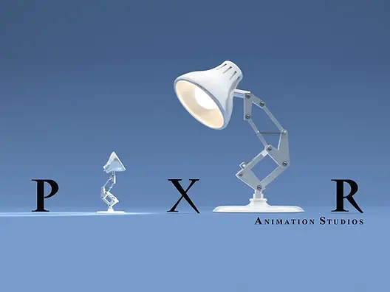
Pixar's Luxo Jr. (1986) — the foundational reference. A desk lamp that conveys a full personality through posture, weight shifts, and timing alone. The parallelogram linkage mechanism is directly adopted from Luxo Jr.'s kinematic chain. Key learning: expressiveness comes from timing and layering of movement, not from complexity of mechanism.
Amazon Echo / Google Home — voice interaction model. Key learning: always-on wake word activation is essential for natural interaction; any push-to-talk friction breaks immersion.
Boston Dynamics robot videos — demonstrates that mechanical objects feel alive when joint movements are slightly asynchronous and have natural deceleration curves, not linear servo sweeps.

3. User Journey
Step 1 — Lamp powers on. The NeoPixel ring fades up to white. The lamp performs a slow "wake stretch" — arm extends upward, head tilts back, then settles into resting position. It's now listening.
Step 2 — User says the wake word (e.g. "Hey Lamp"). The lamp immediately raises its head, tilts forward attentively. The NeoPixel ring shifts to a soft listening pulse.
Step 3 — User speaks a question or command. Audio captured via INMP441 microphone, streamed to the laptop, transcribed by Whisper (STT).
Step 4 — Lamp "thinks." The head tilts to one side. A processing animation plays on the NeoPixels. Claude API receives the transcribed text and generates a response (streamed).
Step 5 — Lamp speaks and moves. Edge TTS converts the reply to audio, played through the PAM8403 speaker. Simultaneously, the lamp's movement matches the response type — nodding for agreement, head-shaking for disagreement, wiggling for excitement.
Step 6 — Music plays nearby. The mic detects the beat using librosa. Joint 6 (mid-arm) bounces up and down in sync. The lamp dances.
Step 7 — User says "track my hand." MediaPipe activates on the laptop webcam. The lamp's base servo rotates to follow the user's hand position in frame.
Step 8 — No interaction. The lamp enters idle mode — slow curious pan and tilt movements, occasional body lean, random "noticing" snaps. It never fully goes still.

4. Success Criteria
Voice pipeline (speech → response → audio)
All 4 servo axes respond to commands
Beat detection triggers bounce
Hand tracking updates lamp direction
System runs stably

5. System Overview
The lamp is split into two computational layers communicating over Wi-Fi WebSocket.
The laptop handles all heavy processing: speech-to-text (Whisper), AI reasoning (Claude API), text-to-speech (Edge TTS), computer vision (MediaPipe), and beat detection (librosa). These tasks exceed the ESP32's capability and run as a Python application on Windows.
The ESP32 is the physical controller: it receives movement commands from the laptop and translates them into PWM servo signals and stepper pulses. It also captures raw audio from the INMP441 microphone and forwards it to the laptop. A second microcontroller, the ESP32-CAM, streams video from the lamp's head for hand tracking.
Main physical parts: 3D-printed PLA parallelogram linkage arm (Luxo Jr. proportions, ~37cm tall), 3 MG996R servos + 2 MG90S servos, 16-LED NeoPixel ring, INMP441 microphone, PAM8403 amplifier, 4Ω 3W speaker, 12V SMPS power supply, LM2596 buck converter.

6. High-Level Block Diagram
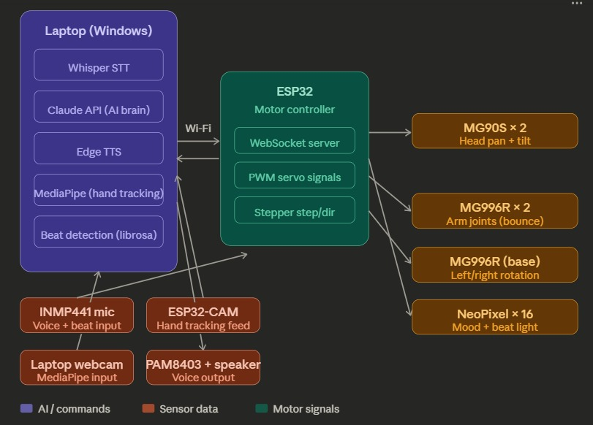

7. Input / Output Mapping
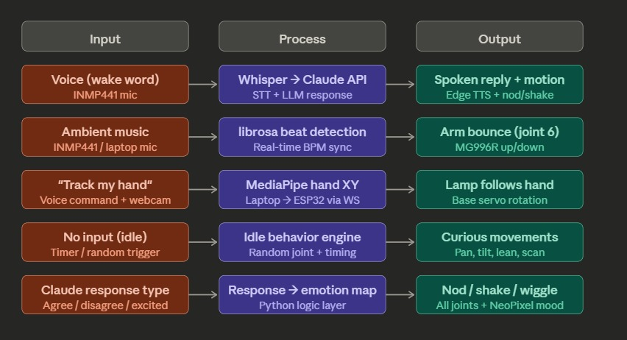

8. Sketches & Concepts
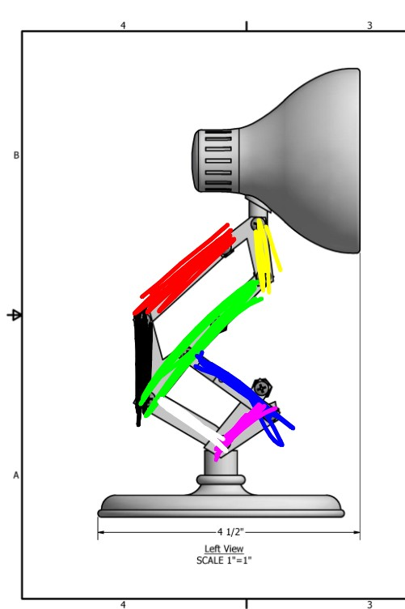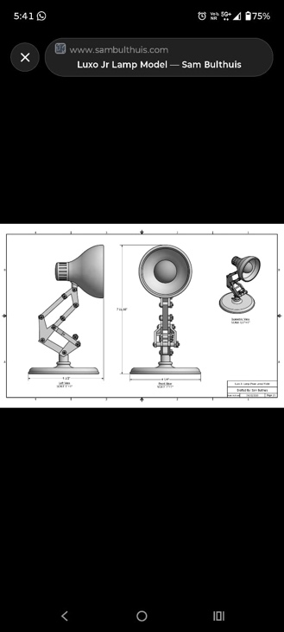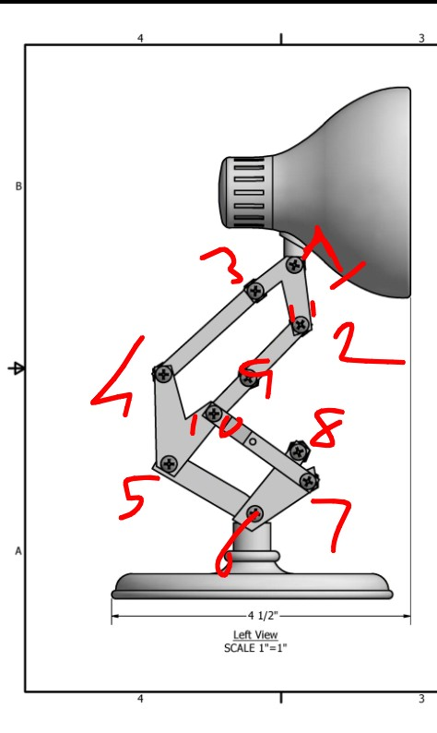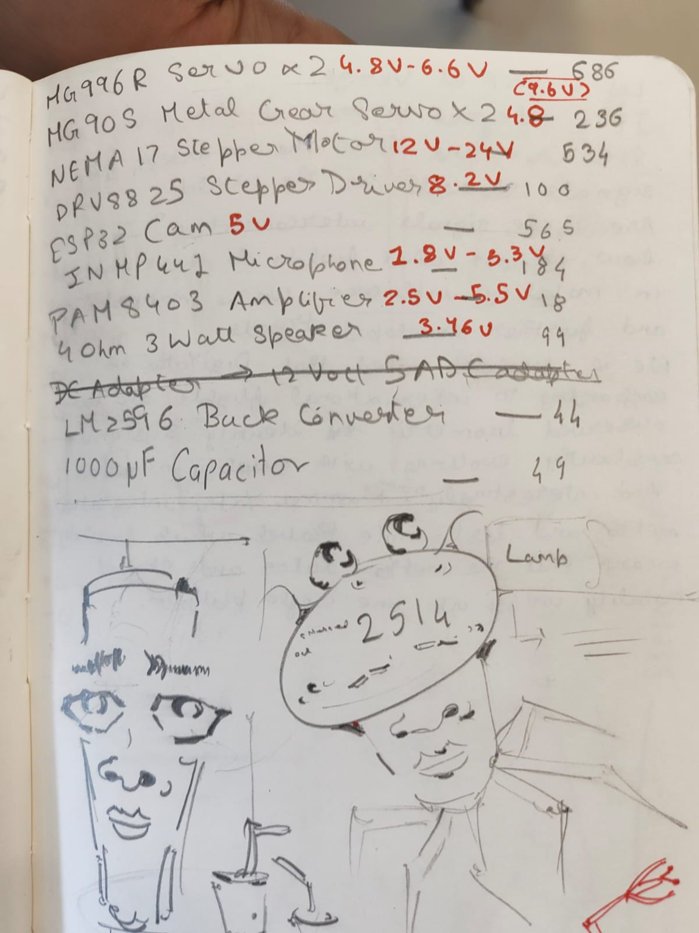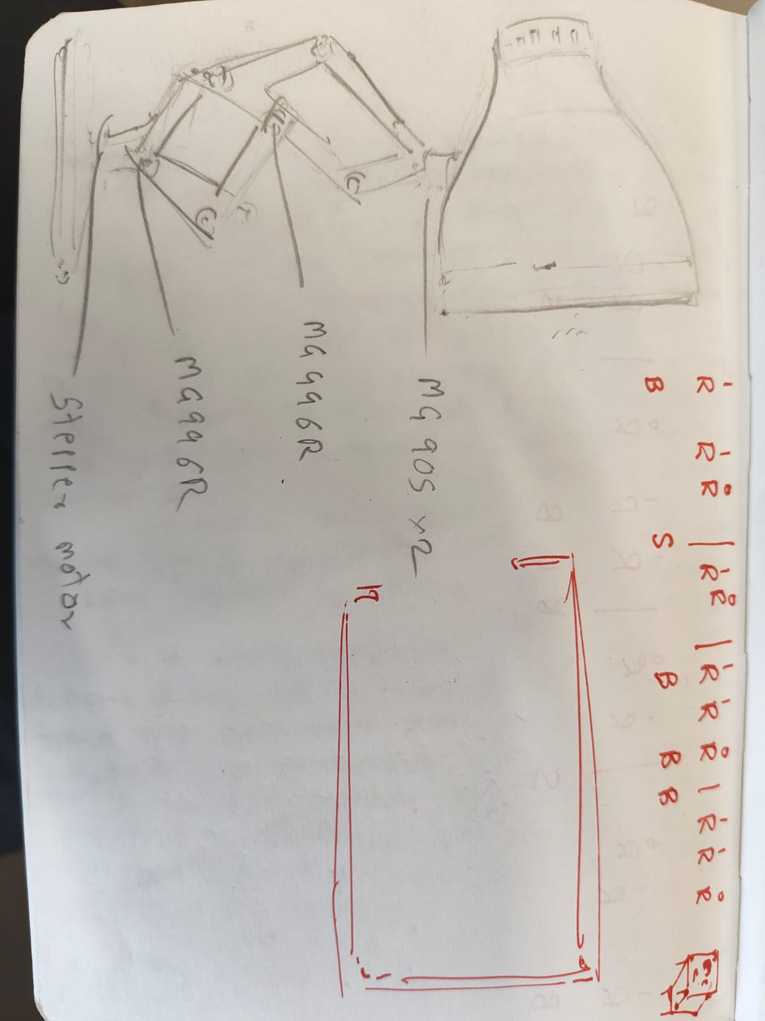

9. Final System Architecture (Labelled)
